Delta College

[Email address]

Read in Scores, Output Data

Program 5 & Design 5

Brett Kriz

// Program (and design) 5

// Brett Kriz

// Typed in Notepad (hastely on someone elses computer)

#include <cmath>

#include <iomanip>

#include <iostream>

#include <fstream>

using namespace std;

// Define functions here

void Read_IN(string des, int& size);

double Average (int A[500], int size);

double STDDev(int A[500], int size, double avg);

void Quartiles (int A[500], int size);

void MaxNMin(int A[500], int size, double& max, double& min);

int scores [500]; // READ_IN was giving me so much hell over arrays

int main() {

system("title Program 5: Test Scores");

system("color 0A");

int x = 0;

int size = 0;

// Clean the new array

while (x < 500){

scores[++x] = -1; // -1 for unused spaces

}// end while

Read_IN("prg5data.txt", size); // oh look modularity

cout << "Checks\n";

// Create all other variables

// average

double avg = Average(scores, size);

// max and min

double max;

double min;

MaxNMin(scores, size, max, min);

// Standard Deviation

double stddev = STDDev(scores, size, avg);

// Display report

char N = '\n';

cout << "Number of Elements:\t" << fixed << size << N;

cout << "Mean:\t" << fixed << avg << N;

cout << "Max:\t" << fixed << max << N;

cout << "Min:\t" << fixed << min << N;

cout << "Standard Deviation:\t" << fixed << stddev << N;

// And show quartiles

Quartiles(scores, size);

system("pause");

return 0;

} // End Main

// Average

double Average (int A[500], int size){

int x = 0;

double ans = 0.0;

while (x<size){

ans += A[++x];

//Adds one after, should return a value similar to the DIM

}// end while

return double(ans/size);

}// end func

void MaxNMin(int A[250], int size, double& max, double& min){

int x=0;

double cur;

max = 0;

min = -1; // lower than able value ;D

while (x<size){ // size = dim

cur = A[++x];

// MIN

if (min == -1 || cur<min){

min = cur;

}

// MAX

if (cur>max){

cur = max;

}

}// end loop

// void return

}// end function

// Standard Deviation

double STDDev(int A[500], int size, double avg){

int x = 0;

double ans = 0.0; // 0.0" lol

while (x<size){ // size = dim

ans += double(pow(A[++x] - avg, 2)); // what a mouthfull

// so its the xth value - average, quantity squared

} // end loop

// return the sqrt of ans divided by size - 1

return sqrt(ans/(size - 1));

} // end func

//now, quartiles

void Quartiles (int A[500], int size){

// vars

int x = 0;

int Q1 = 0;

int Q2 = 0;

int Q3 = 0;

int Q4 = 0;

int cur = 0;

while (x<size){ // size = dim

cur = A[++x];

if (cur >=75 && cur <= 100){

Q4++;

}else if(cur >=50 && cur < 75){

Q3++;

}else if(cur >= 25 && cur < 50){

Q2++;

}else if(cur >= 0 && cur < 25){

Q1++;

}else{

int z = x-1;

cout << fixed << "\nBad # @" << z << "! With value:\t" << A[z] << "\a";

}

} // end while

cout << "\nQ1:\t" << fixed << Q1;

cout << "\nQ2:\t" << fixed << Q2;

cout << "\nQ3:\t" << fixed << Q3;

cout << "\nQ4:\t" << fixed << Q4 << endl;

}// end func

// READ IN FILE

void Read_IN(string des, int& size){

//int AA[500];

ifstream IN;

int x = 0;

IN.open(des); // Modularity >:3

if (IN.is_open()){

system("color 09");

while(!IN.eof()){

IN >> scores[++x]; // Load items

//system("echo + ");

int prev = scores[x-1];

// Something for checks

//if (prev ==

cout << prev << ","; // for fun

} // end loop

cout << "\nRead in complete!\n";

system("pause");

system("cls");

system("color 0A");

size = x; // Will equal dim of A[]

// not open?

}else{

cout << "\n\nInput File is empty! Check path!\a";

//cout << des << endl; //This wont work... idk

// '<<' : no operator found which takes a right-hand operand of type 'std::string' (or there is no acceptable conversion)

system("color CA");

system("pause");

system("color 0A");

}// end if

IN.close();// Better close that...

//return AA[500];

}// end func

OUTPUTS:

Read File: 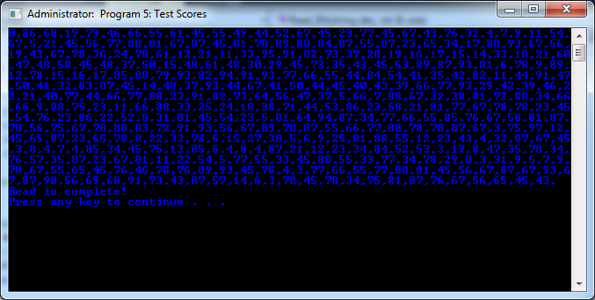  
 Outputs: (Yes, it changes color lol)

